**[Griffiths](https://docs.google.com/document/d/1Hmlp39B4ErLKe3b8TO1vQpZW5r9T0sCYiy9b404jAr8/edit?usp=sharing) et al,**

**Figures and Tables**

**Table 2.** Summary statistics from a two-way PERMANOVA investigating the effects of *Smithora* and transplant on bacterial community.

Df F.Model R2 Pr(>F)

Transplant 2 8.0805 0.26703 0.001 ***

*Smithora*_status 2 7.7425 0.25586 0.001 ***

Transplant*Smithora status 2 2.4375 0.08055 0.005 **

**Table 3.** Table of bacterial results

Differences in diversity could be driving these changes

K AICc Delta_AICc AICcWt Cum.Wt LL

transplant 3 239.44 0.00 1 1 -116.09

smithTrans 8 306.05 66.61 0 1 -141.75

smith 4 312.62 73.18 0 1 -151.54

null 2 314.99 75.55 0 1 -155.28

Transplant is the most important factor dictating diversity. It could also be part of the time component.

**FIGURE 1**. A) Study site at Calvert Island BC. B) Choked pass, site of experimental transplants and surveys of *Smithora* *naiadum* and *Zostera marina.* Twelve sites in the meadow were surveyed using 40 m transects. *Smithora* abundance (biomass? Visually estimated abundance?) on *Z. marina* at each sampled site is represented by red circles. C) Smithora biomass / Zostera biomass at edge vs interior (circled) sites (n = 4). The site of the reciprocal transplant is WF (lower left).

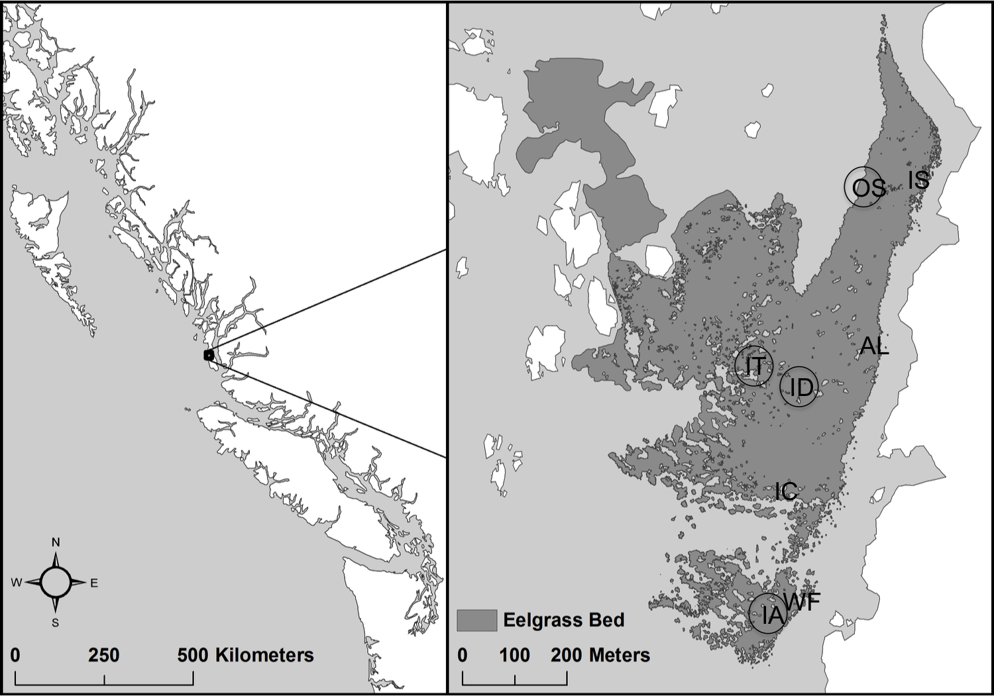

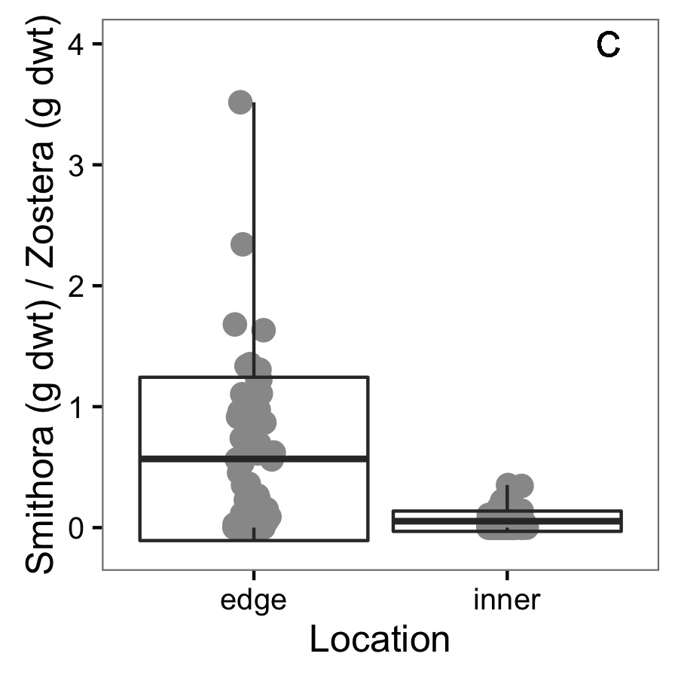

**Figure 2.** Conditions at the two experimental transplant sites (WF and IA) before the experiment. For six replicate samples of 0.0625 m2 of seagrass meadow, A) *Z. marina* dry weight of above ground biomass, B) *Smithora* dry weight biomass (per *Z. marina* shoot biomass) C) grazer abundance / X g shoots, and D) seagrass surface bacterial assemblages varied significantly. See appendix for grazer composition comparison.

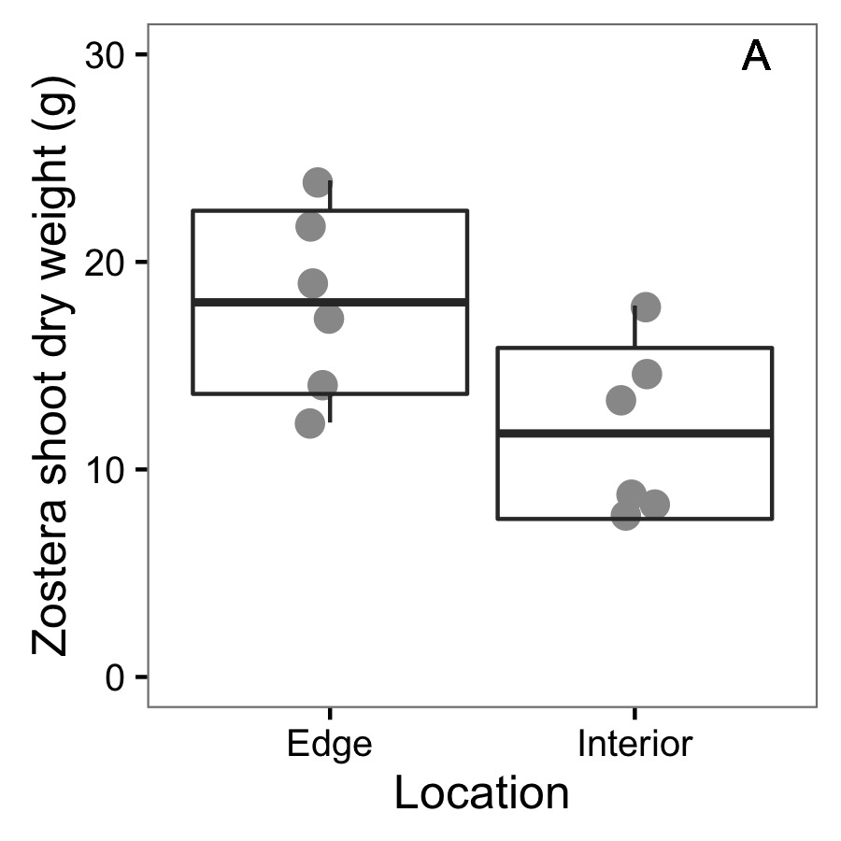 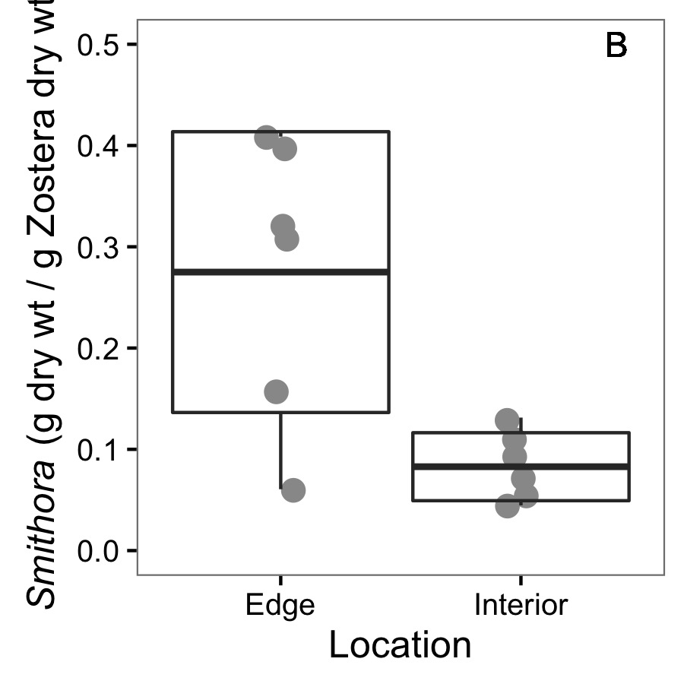

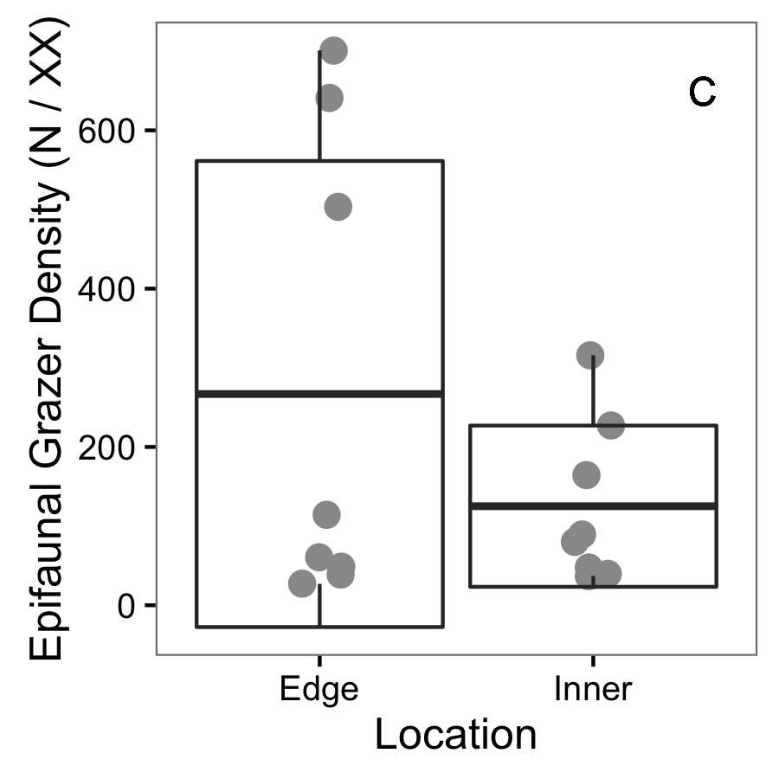C is a placeholder, and D is waiting for marcus

**Figure 3**. Final *Smithora* abundance (g / g *Zostera* dry wt) for experimental and control shoots in the reciprocal transplant experiment. Box indicates mean and 1 standard deviation.

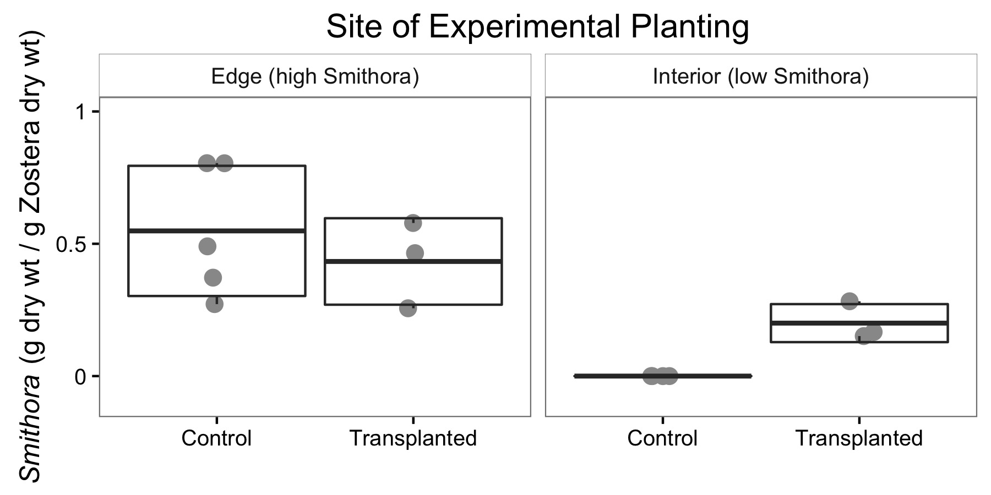

**APPENDIX:**

Figure A1: *Zostera marina* shoot density at transplant sites.

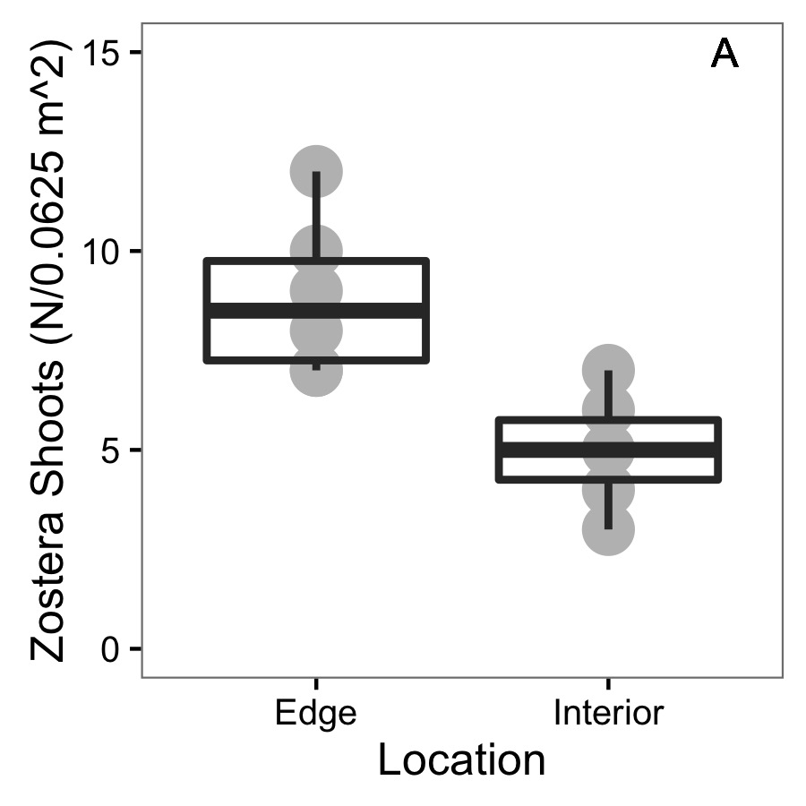

Figure A2: NMDS for grazer assemblages at transplant sites before experiment

Figure A3: Bacterial results after experiment, waiting for Marcus.